**INSTITUTE OF ENGINEERING & TECHNOLOGY**

**MOHANLAL SUKHADIA UNIVERSITY, UDAIPUR**

**(RAJ.)**

***DEPARTMENT OF COMPUTER SCIENCE ENGINEERING***

***B. Tech - IV SEMESTER***



**Session 2022-23**

**Java Lab**

**LABORATORY MANUAL**

**BT4CS11-CP05**

**Prepared by:**

**Shivam Chouhan**

**INDEX**

|  |  |  |  |  |
| --- | --- | --- | --- | --- |
| S.No. | Topic | Date | Grade | Signature |
| 1. | WAP to print Hello World |  |  |  |
| 2. | WAP to perform addition of two numbers |  |  |  |
| 3. | WAP to find square root of a number |  |  |  |
| 4. | WAP to swap two numbers using third variable |  |  |  |
| 5. | WAP to perform product of two floating numbers |  |  |  |
| 6. | WAP to find factorial of a number |  |  |  |
| 7. | WAP to find reverse of a number |  |  |  |
| 8. | WAP to print star pyramid pattern by entering number of rows |  |  |  |
| 9. | WAP to check whether the given year is leap or not |  |  |  |
| 10. | WAP to find frequency of each element |  |  |  |
| 11. | WAP to print array in reverse order |  |  |  |
| 12. | WAP to print Fibonacci Series |  |  |  |
| 13. | WAP to print reverse star pyramid pattern |  |  |  |
| 14. | WAP to print elements present at odd position of the array |  |  |  |
| 15. | WAP to print smallest element in array |  |  |  |
| 16. | WAP to print jagged array |  |  |  |
| 17. | WAP to find product of two matrices |  |  |  |
| 18. | WAP to find transpose of given matrix |  |  |  |
| **INDEX** | | | | |
| S.No. | S.No. | Date | Grade | Signature |
| 19. | WAP to find whether a given matrix is identity matrix or not |  |  |  |
| 20. | WAP to find sum of each row and column in the given matrix |  |  |  |
| 21. | WAP having class a Dog with data members name, breed, age, color. Print the above characteristics of any three dogs |  |  |  |
| 22. | WAP to show the concept of default constructor |  |  |  |
| 23. | WAP for Constructor Overloading/ Constructor chaining |  |  |  |
| 24. | WAP for implementation of Copy Constructor |  |  |  |
| 25. | WAP to show use of “extends” keyword |  |  |  |
| 26. | WAP to show scope of private modifier |  |  |  |
| 27. | WAP to show scope of public modifier |  |  |  |
| 28. | WAP to show scope of protected modifier |  |  |  |
| 29. | WAP to show scope of default modifier |  |  |  |
| 30. | WAP to implement Java Try Catch block |  |  |  |
| 31. | WAP to implement Java Try finally block |  |  |  |
| 32. | WAP to implement Java Try Catch finally block |  |  |  |
| 33. | Write a Java program to create a new file |  |  |  |

**JAVA Lab Practical-1**

Q1. Write a Java Program to print Hello World .

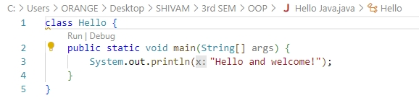**Program**

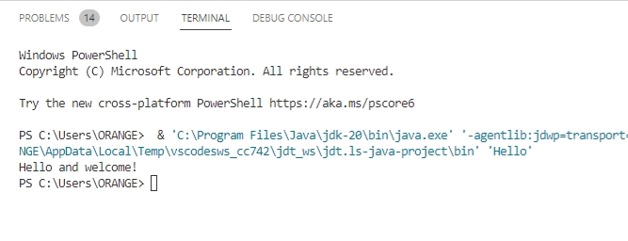**Output**

**JAVA Lab Practical -2**

Q2. Write a Java Program to perform Addition of two numbers.

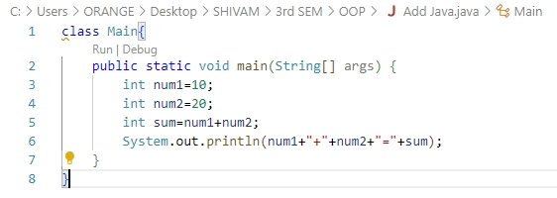**Program**

**Output**

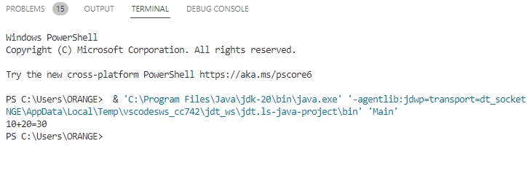

**JAVA Practical -3**

Q3. Write a Java Program to find square root of number.

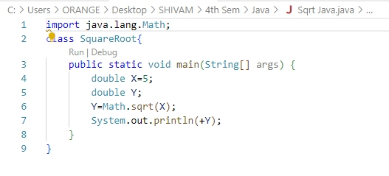**Program**

**Output**

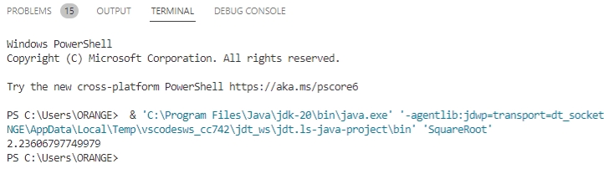

**JAVA Lab Practical -4**

Q4.Write a Java Program to swap two numbers using third variable .

**Program**

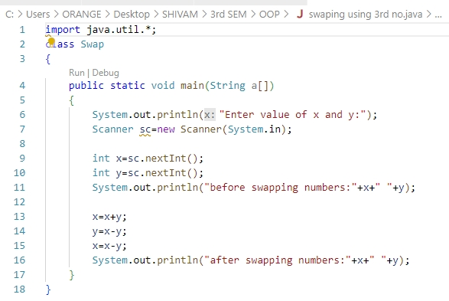

**Output**

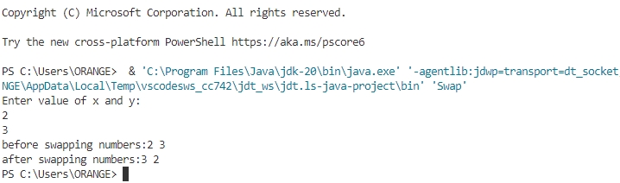

**JAVA Lab Practical-5**

Q5. Write a Java Program to perform product of two floating number.

**Program**

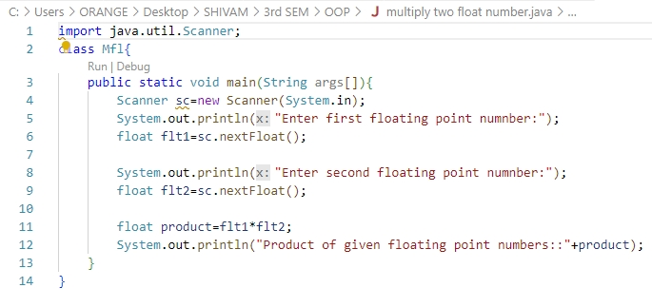

**Output**

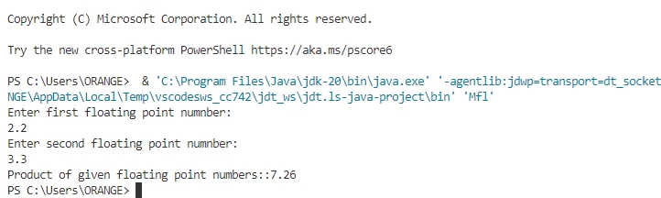

**JAVA Lab Practical-6**

Q6. Write a Java Program to find factorial of a number.

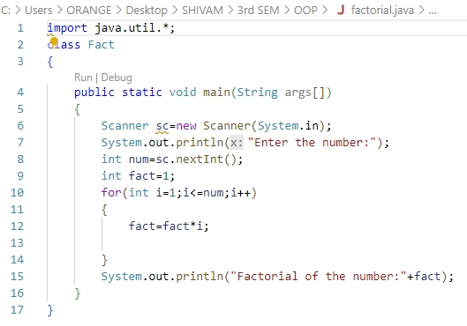**Program**

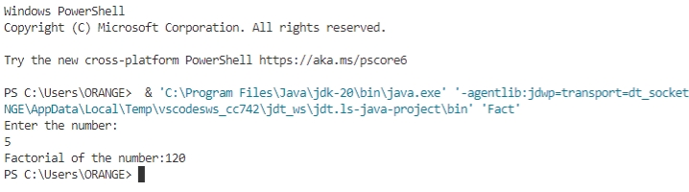**Output**

**JAVA Lab Practical-7**

Q7. Write a Java Program to find reverse of a number.

**Program**

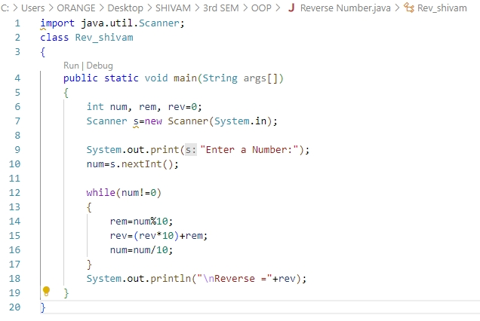

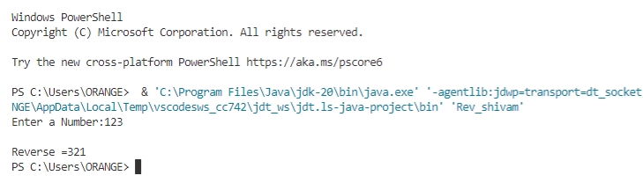**Output**

**JAVA Lab Practical-8**

Q8. Write a Java Program to print star pyramid pattern by entering number of rows.

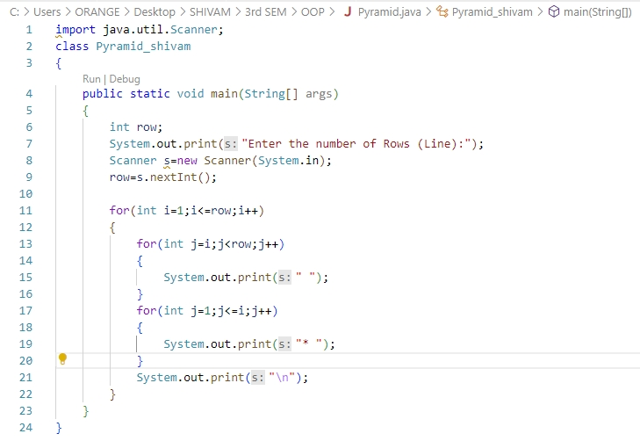**Program**

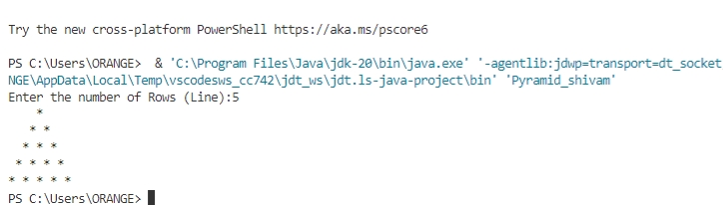**Output**

**JAVA Lab Practical-9**

Q9. Write a Java Program to check whether the given year is leap or not.

**Program**

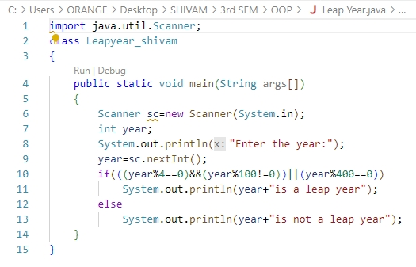

**Output**

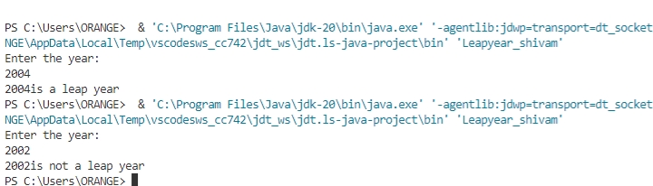

**JAVA Lab Practical-10**

Q10. Write a Java Program to find frequency of each element.

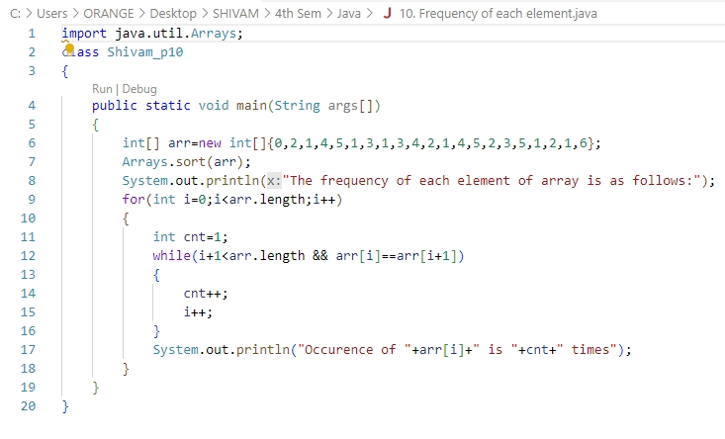**Program**

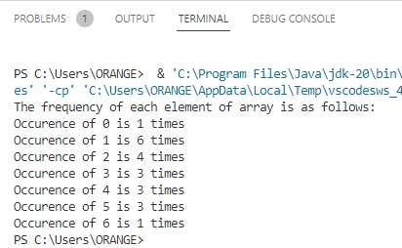**Output**

**JAVA Lab Practical-11**

Q11. Write a Java Program to print array in reverse order.

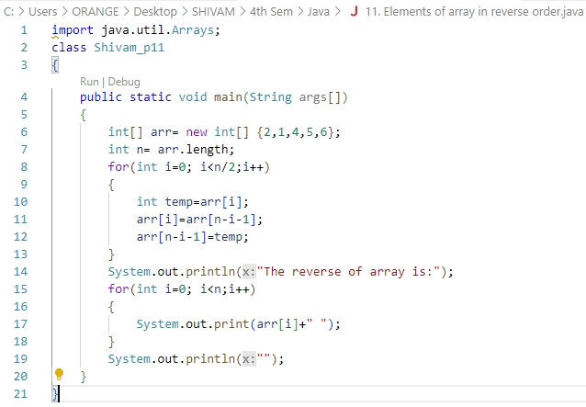**Program**

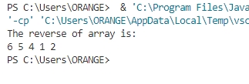**Output**

**JAVA Lab Practical-12**

Q12. Write a Java Program to print Fibonacci Series.

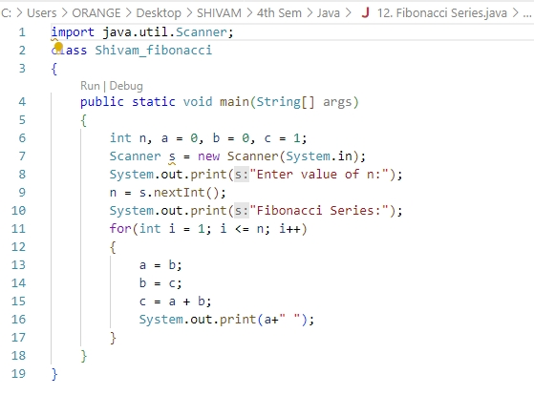**Program**

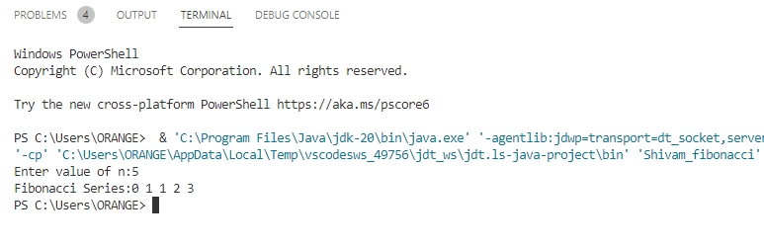**Output**

**JAVA Lab Practical-13**

Q13. Write a Java Program to print reverse star pyramid pattern.

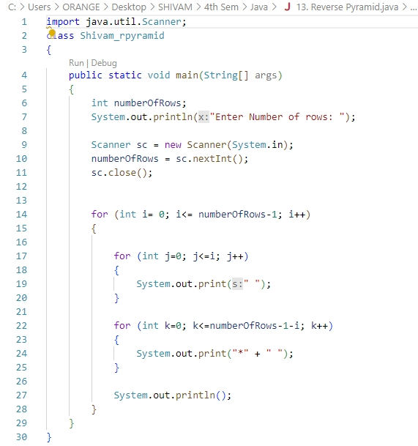**Program**

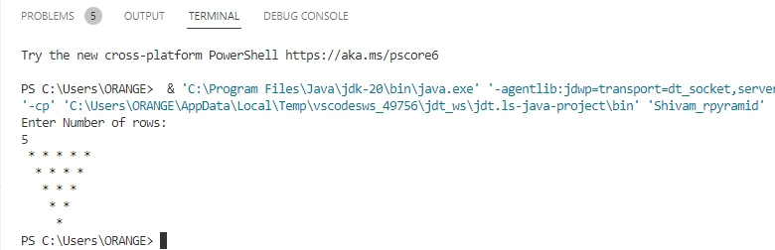**Output**

**JAVA Lab Practical-14**

Q.14 Write a Java Program to print elements present at the add position of the

array.

**Program**

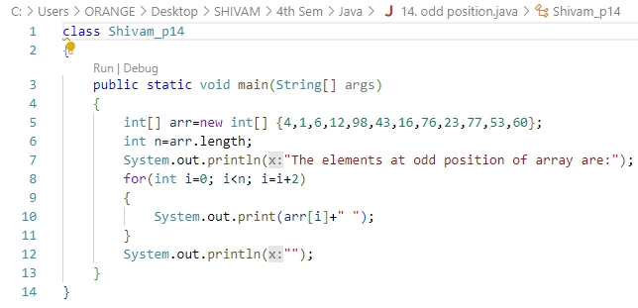

**Output**

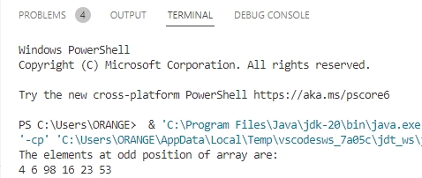

**JAVA Lab Practical-15**

Q.15 Write a Java Program to print the smallest element in the array.

**Program**

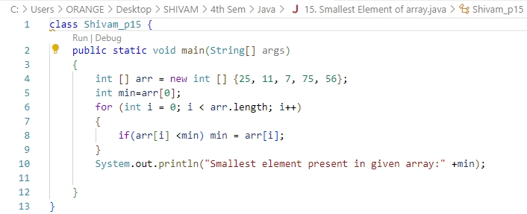

**Output**

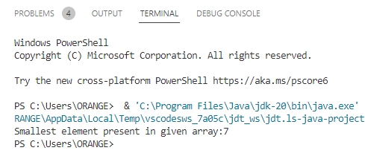

**JAVA Lab Practical-16**

Q.16 Write a Java Program to print jagged array.

**Program**

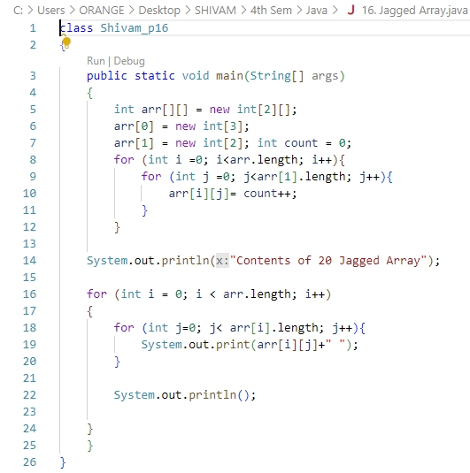

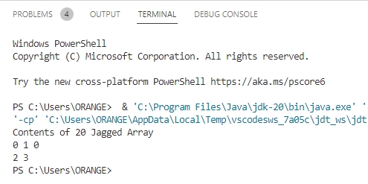**Output**

**JAVA Lab Practical-17**

Q.17 Write a Java Program to find product of two matrices.

**Program**

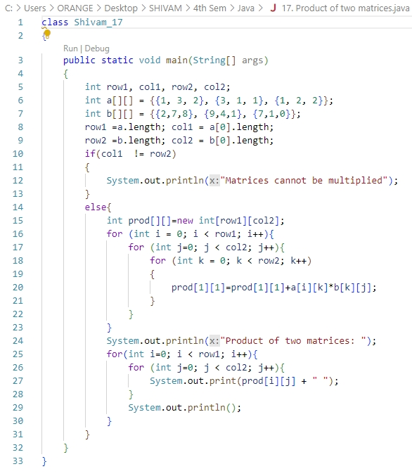

**Output**

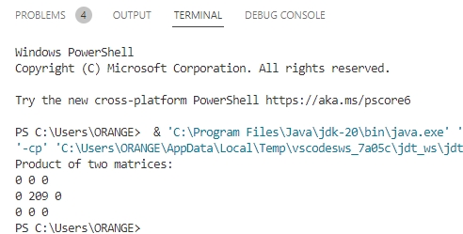

**JAVA Lab Practical-18**

Q.18 Write a Java Program to find transpose of given matrix.

**Program**

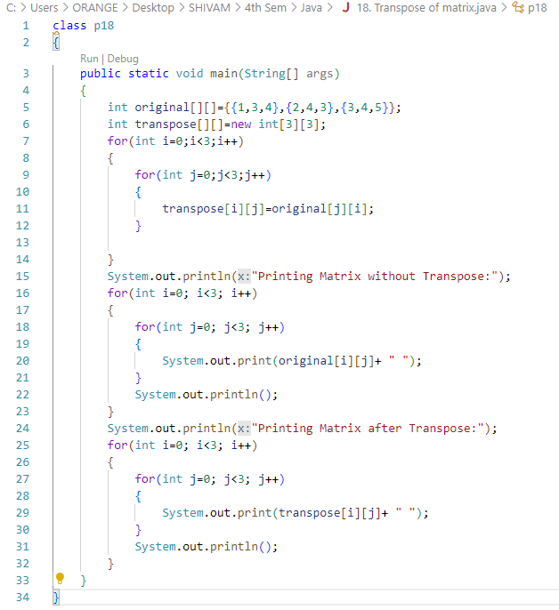

**Output**

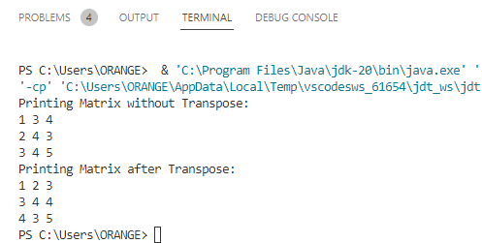

**JAVA Lab Practical-19**

Q.19 Write a Java Program to find whether a given matrix is identity matrix or not.

**Program**

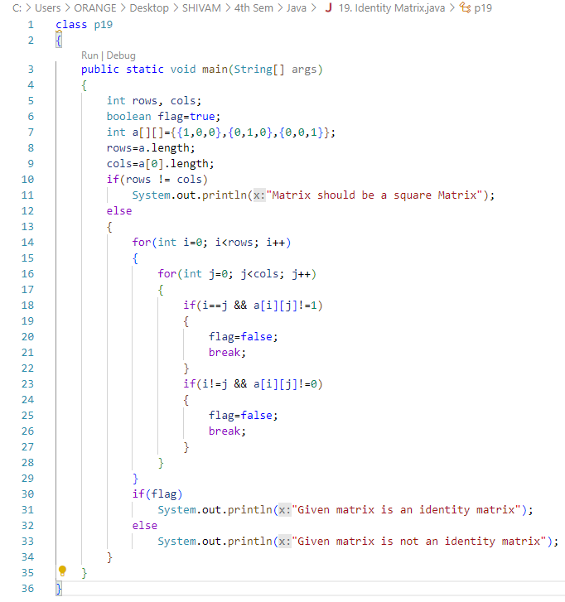

**Output**

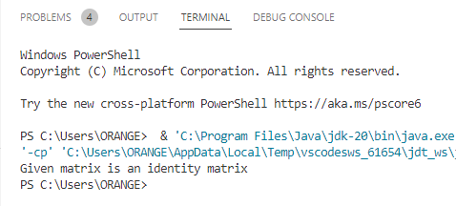

**JAVA Lab Practical-20**

Q.20 Write a Java Program to find sum of each row and column in the given matrix.

**Program**

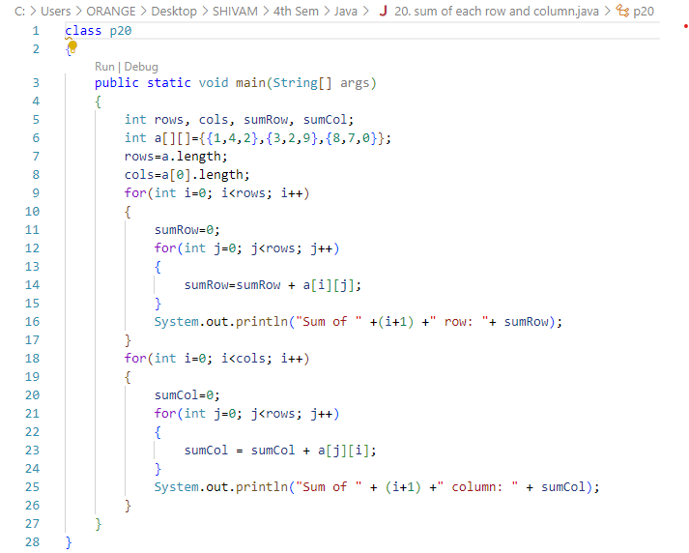

**Output**

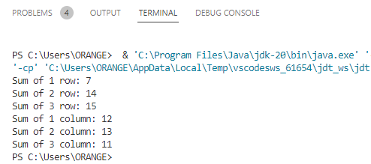

**JAVA Lab Practical-21**

Q.21 Write a Java Program having class Dog with data members name, breed, age, color. Print the above characteristics of any three dogs.

**Program**

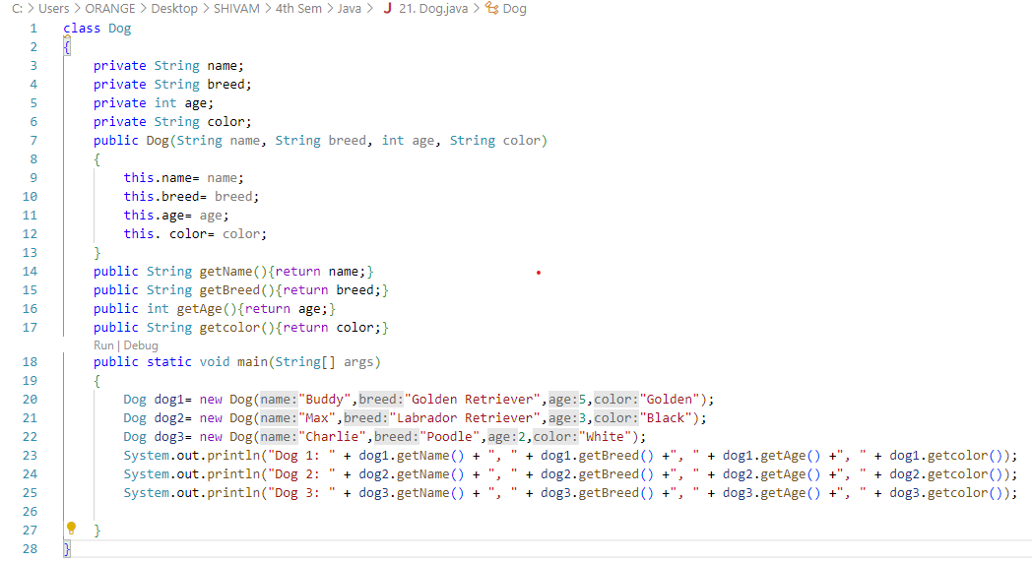

**Output**

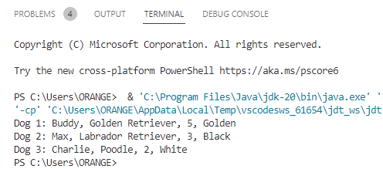

**JAVA Lab Practical-22**

Q.22 Write a Java Program to show the concept of default constructor .

**Program**

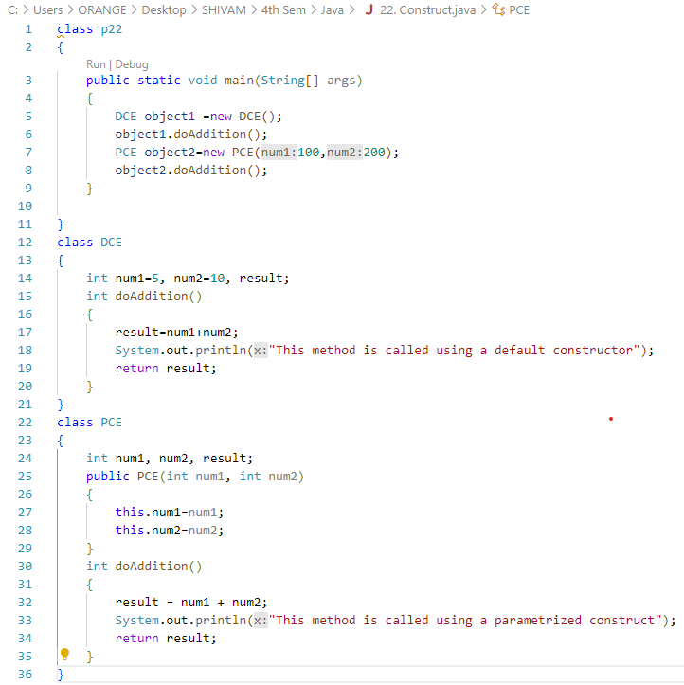

**Output**

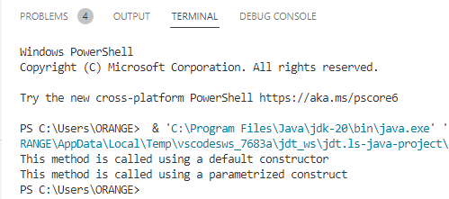

**JAVA Lab Practical-23**

Q.23 Write a Java Program for Constructor Overloading/ Constructor chaining.

**Program**

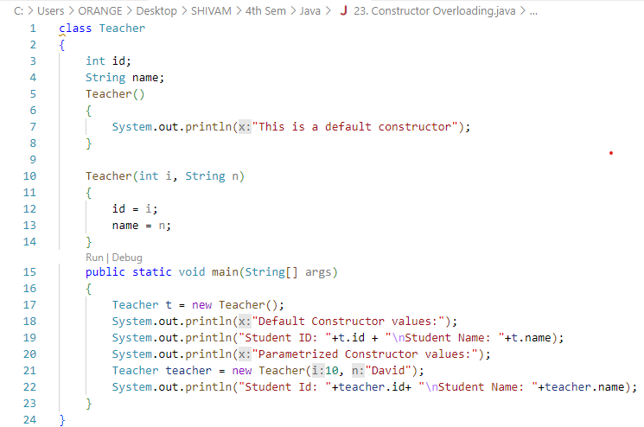

**Output**

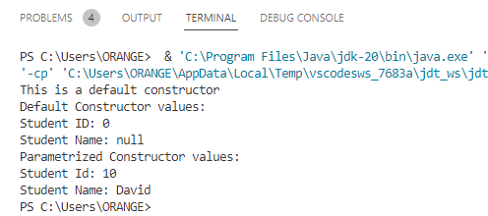

**JAVA Lab Practical-24**

Q.24 Write a Java Program for implementation of Copy Constructor.

**Program**

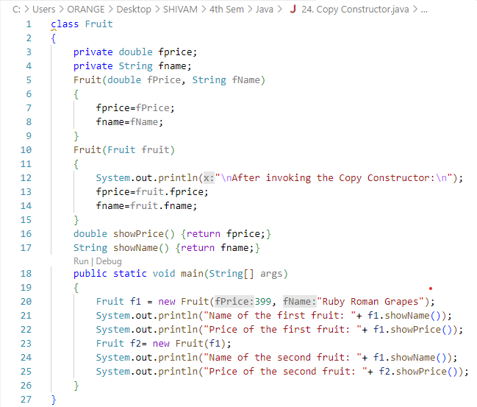

**Output**

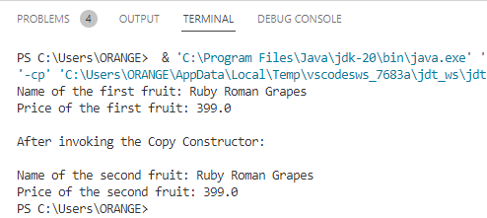

**JAVA Lab Practical-25**

Q.25 Write a Java Program to show use of “extends” keyword.

**Program**

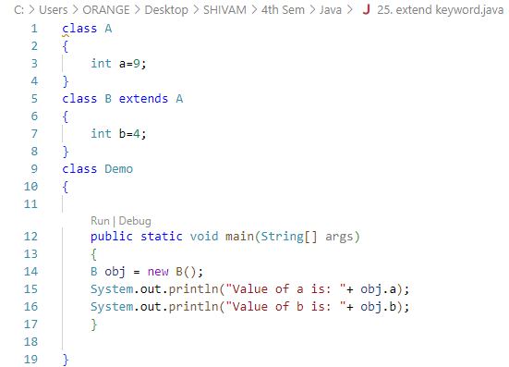

**Output**

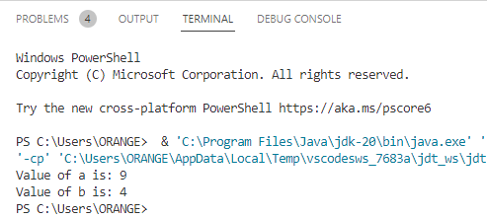

**JAVA Lab Practical-26**

Q.26 Write a Java Program to show scope of private modifier.

**Program**

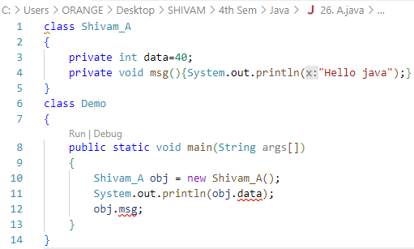

**Output**

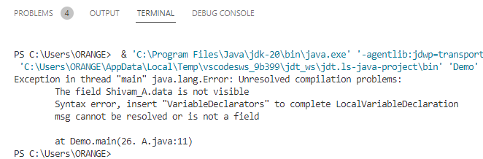

**JAVA Lab Practical-27**

Q.27 Write a Java Program scope of public modifier.

**Program 1:**

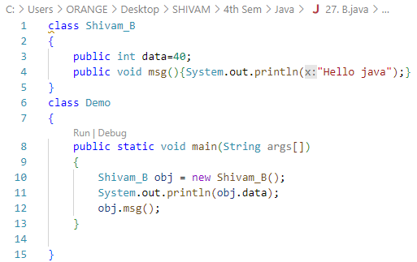

**Output 1:**

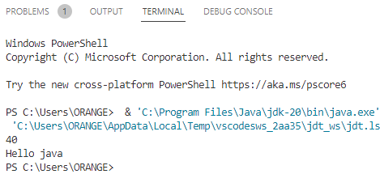

**Program 2:**

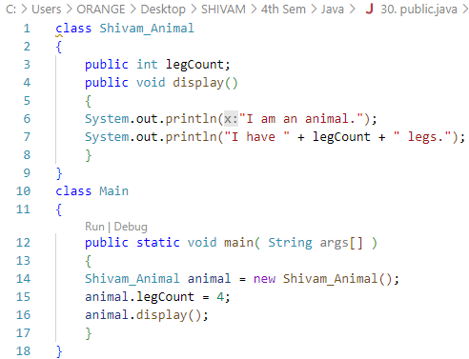

**Output 2:**

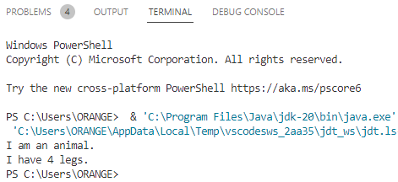

**JAVA Lab Practical-28**

Q.28 Write a Java Program to show scope of protected modifier.

**Program**

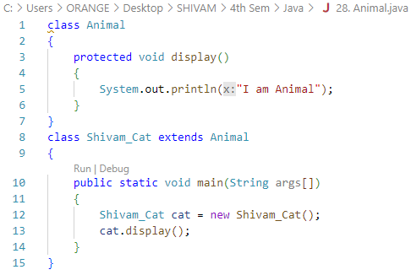

**Output**

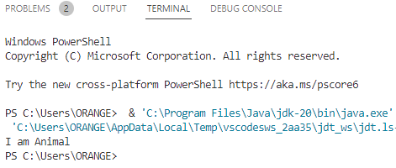

**JAVA Lab Practical-29**

Q.29 Write a Java Program to show scope of default modifier.

**Program**

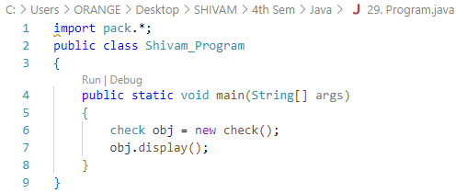

**Output**

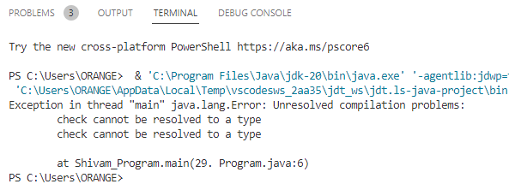

**JAVA Lab Practical- 30**

Q.30 Write a Java program to implement Java Try Catch block

**Program**

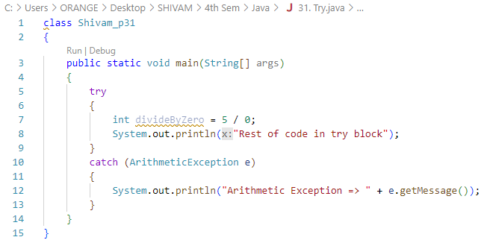

**Output**

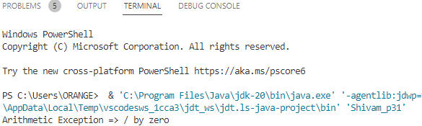

**JAVA Lab Practical- 31**

Q.31 Write a Java program to implement Java Try finally block.

**Program**

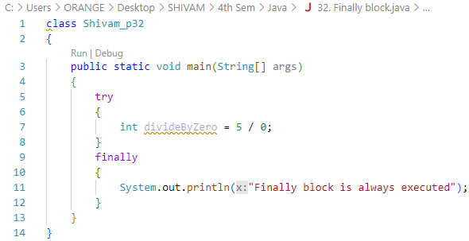

**Output**

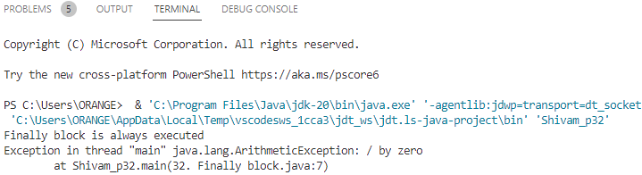

**JAVA Lab Practical- 32**

Q.32 Write a Java program to implement Java Try Catch finally block.

**Program**

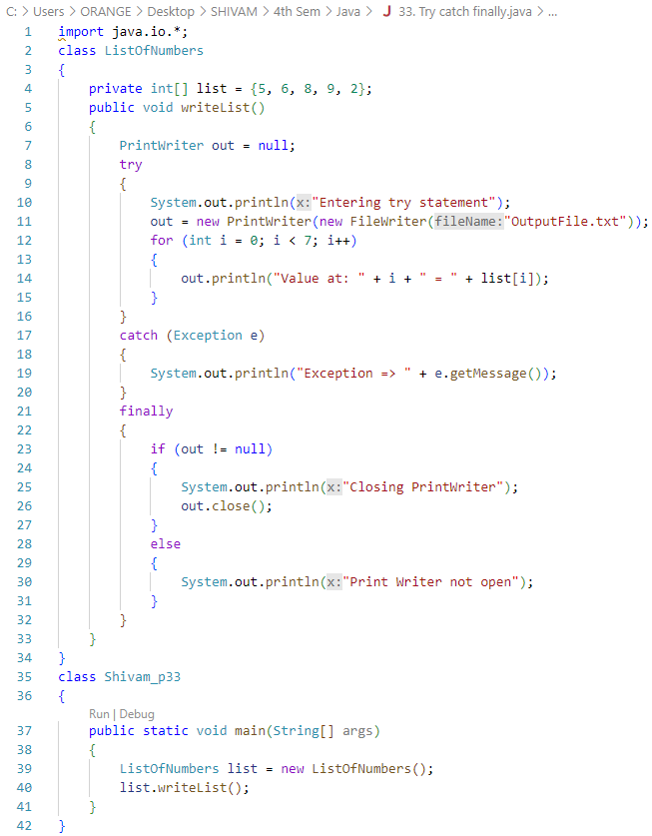

**Output**

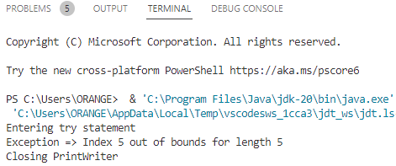

**JAVA Lab Practical- 33**

Q.33 Write a Java program to create a new file.

**Program**

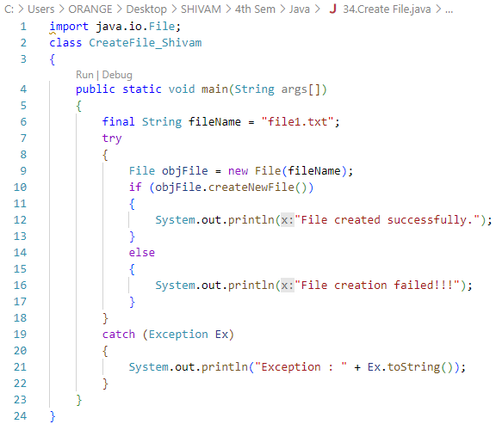

**Output**

